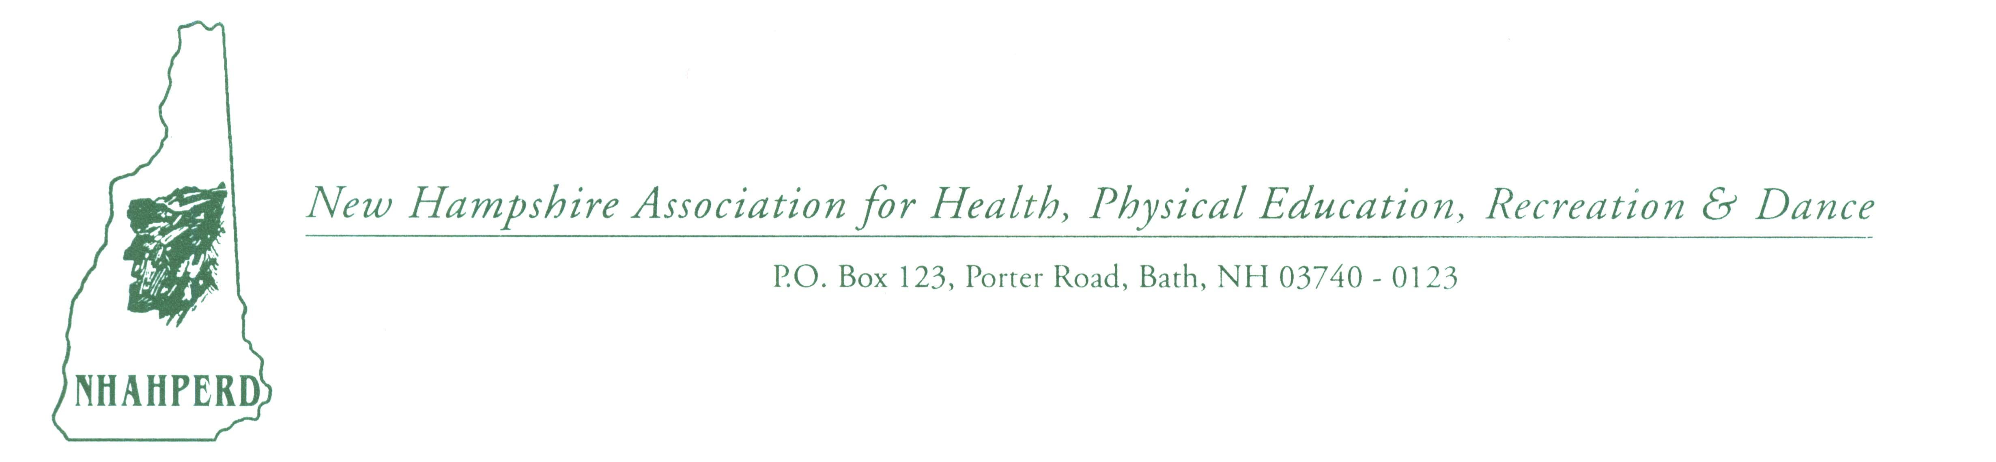
MEMBERSHIP APPLICATION FORM
Join the Association and lend support through strength of members
and through your professionalism!
(Membership year runs from 9/1 - 8/31)
DUES
Professional ($30.00) $ _______
Student ($15.00) $ _______
Retired ($0.00) _______
Please make checks payable to: NHAHPERD
and mail to: Dianne Rappa, P.O. Box 123, Bath, NH 03740

PLEASE FILL IN BELOW:

NAME: ________________________________________________

*Please check preferred mailing address
____ School/Business Address ____ Home Address

School: ___________________________ Address: _________________________
Address: ___________________________ _________________________________
___________________________ _________________________________
Phone: ___________________________ Phone: ___________________________
Fax: ___________________________ Fax: ___________________________
Email: ___________________________ Email: ___________________________

PRIMARY AREA OF INTEREST: (Please check appropriate area(s)

____ Physical Education ____ Health ____ Recreation ____ Dance ____ Agency ____ Other: ________________________________________

LEVEL OF EMPLOYMENT: (Please check appropriate area(s))

____ Preschool ____ Elementary ____ Middle ____ Secondary ____ College/University ____ Agency ____ Other: ______________________________

Would you be willing to serve on the NHAHPERD Executive Board &/or an ad hoc committee? Public Relations/Advocacy, Newsletter, Awards, Conference (present/preside), Retiree Network
Comments: _________________________________________________________________
_________________________________________________________________
Thanks! Feel free to contact me with questions, requests & concerns: Dianne Rappa, P.O.B.123, Bath, NH 03740; 747-3508; 747-2408(F) email: drappa@roadrunner.com ; www.nhahperd.org

