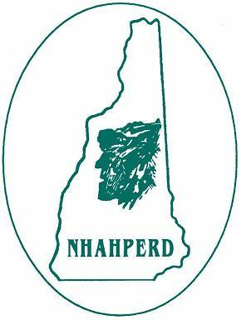
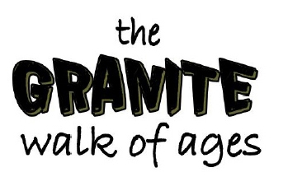
The Granite State
nhmoves.org

May 31, 2019
Concord, NH

Granite Walk of Ages: The “Granite Walk of Ages” is a statewide health initiative, centered on bringing together towns, cities, schools, organizations and businesses in New Hampshire. This walk focuses on prevention, increased physical activity and employee health.
Use this as your ‘Trial Mile’ for the 90-Day Challenge*, beginning June 1st!
Agenda for Granite Walk of Ages

11:45am Sign-in Registration – State House Capitol
12:00 – 12:30 1 mile walk around Capitol Area

Individual Registration I will participate in the kick-off event in Concord/State House on May 31.
Group/Team Registration We will participate in the kick-off event in Concord/State House May 31
Individual/Group Registration as a Satellite Event May 31, 2019
To register on-line as an individual or group for the GWA/Concord, NH contact:
Dianne Rappa by May 15 - drappa@roadrunner.com; 603-747-3508 w/?’s
Be first 100 to register & attend the Concord Walk by 5/1 to receive free tshirt: Circle one: S M L XL
(To register as a satellite event for the GWA please specify below – Thank you!!)

CC Registrant Name/Team Contact:

Add Company/organization/school:

CC Address/city/zip:

Phone Number:

Email:

Expected # Participants:
(for schools and groups)
*To register for the Granite State 90 Day Challenge, visit www.nhmoves.org/90daychallenge, complete
and submit the online registration form. It’s FREE, easy to participate & good for your health! Use the emailed Passport to track your daily activity & gain free access to select State Parks.
See Passport for eligibility details.

