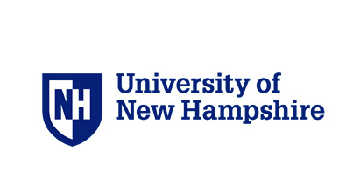

For more information contact:

Michelle Grenier- [michelle.grenier@unh.edu](mailto:michelle.grenier@unh.edu)

Samantha Winn

[Sew2006@wildcats.unh.edu](mailto:Sew2006@wildcats.unh.edu)

University of New Hampshire • Kinesiology Department • Health & Physical Education

<https://www.events.unh.edu/RegistrationForm.pm?event_id=22964>

**4th Annual**

Join us for our 4th Annual Adapted Physical Education Conference. This will be a day filled with workshops and activity sessions to further your knowledge in Adapted Physical Education! Our guest presenter will be APE national teacher of the year **Brad Weiner**

Topics include:

* Assessments
* Universal Design and Access
* Climbing Wall Activities
* Adapted Sports
* Skateboarding
* Yoga
* Transition experiences

*University of New Hampshire Health & Physical Education Department of Kinesiology*

**Adapted Physical Education Conference**

**PLEASE JOIN US!**

**Friday**

**April 20th, 2018**

**8:30am-2:30pm**

**NHH**