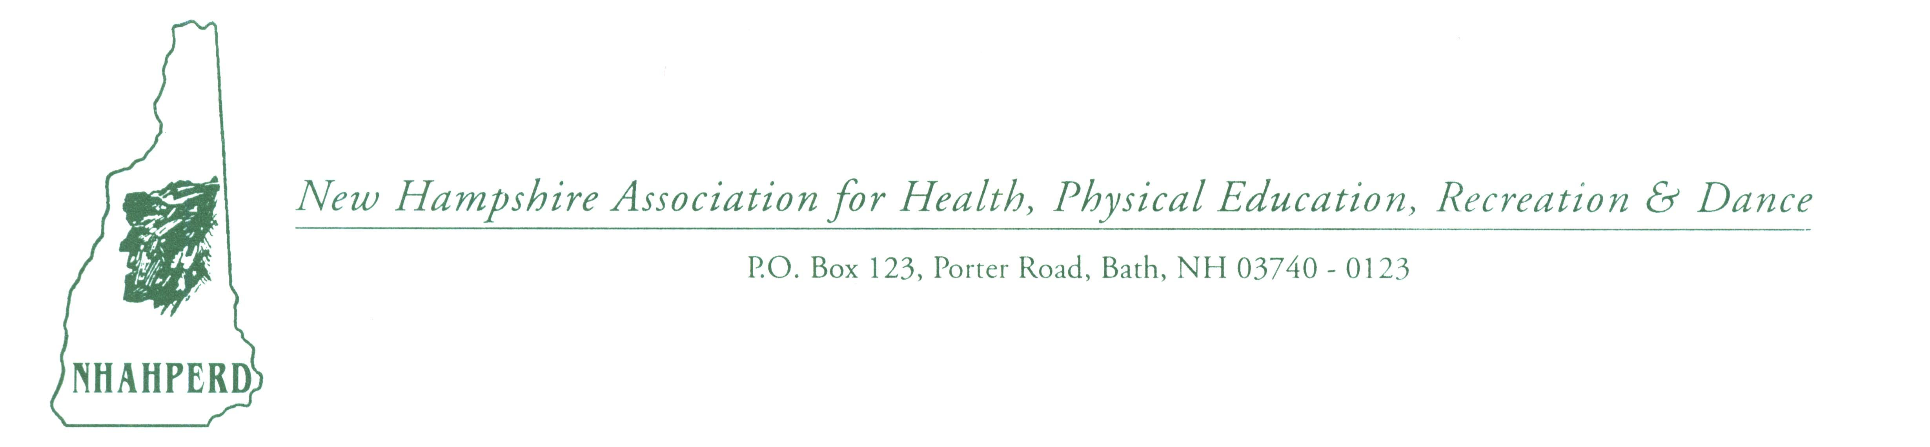
Dear Exhibitor: January 2024

We are looking forward to your participation in our upcoming 2024 NHAHPERD conference. The following information is provided to help you make final arrangements for your exhibit.

# of participants: 450 – 500 Physical Educators, Health, Dance & Recreation Related Professionals, Students and Retirees

Date: November 21, 2024 Thursday & November 22, 2024 Friday
Time: Exhibit Time 7:30 a.m. - 4:00 p.m. Thursday & Friday 7:30 a.m. – 2:00 p.m.
Exhibitor Cost: $90 per day; $200/two days includes 6 ft. table w/skirt & electricity (please specify if need electricity), & one lunch/meal ticket (value $25 - additional tickets can be purchased, please specify on form below.)
$80 - catalog display for our resource table(s) or digital inclusion in our Handout Booklet if you can't attend. Resources/catalogs may be mailed to Dianne Rappa or .pdf for inclusion in our handout booklet sent by 11/10.
(Area is locked at night – you may keep items in exhibit area for 2nd day)
If you would like to sponsor a morning beverage break, lunch, Awards Banquet, Keynote, Silent Auction &/or ‘giveaways’- please notify me – WE NEED YOU!
Door prizes are encouraged from your companies as we have drawings throughout the conference and during our closing activities Friday.
Location: Waterville Valley Convention & Resort Center, 56 Packard’s Road,
Waterville Valley, NH 03215 (Exit 28 off Interstate I-93) 603-236-8311x3012
(Discounted lodging fares: Silver Fox: 603-236-3699, Valley Inn: 603-236-8425, Black Bear Lodge: 603-236-4501, Snowy Owl: 603-236-8383, Town Square: 603-236-8175 & mention NHAHPERD Conference)

If you have any questions on fees, conference, mailing, presenting, etc. please contact:
Dianne L. Rappa, NHAHPERD Executive Director
P.O. Box 123-258 Porter Road; Bath, NH 03740-0123
603-747-3508 (H/B); 603-481-1852 (C); drappa@roadrunner.com; www.nhahperd.org

(Please return below ASAP)
- - - - - - - - - - - - - - - - - - - - - - - - - - - - - - - - - - - - - - - - - - - - - - - - - - - - - - - - - - - - - - - - - - -
Confirmation: Total Cost Enclosed: _______________
# of Days: (specify): _______________
Please submit check payable to NHAHPERD & return to:
Dianne L. Rappa, P.O. Box 123, Bath, NH 03740

Name (Company): _____________________________________________________________
Address: _____________________________________________________________________________
_____________________________________________________________________________
Additional Comments:
_____________________________________________________________________________

Thank you!

