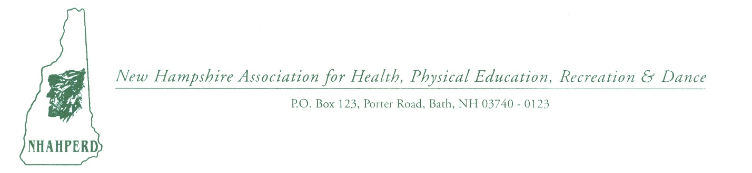
Request for Sponsorship for NHAHPERD’s 2nd Annual Family Fun Run/Walk 5K

The NH Association for Health, Physical Education, Recreation and Dance (NHAHPERD) is holding the 2nd Annual Family Fun Run/Walk 5K Sunday, June 2nd, 2019. The event will be held in Concord NH at the NHTI Delta Dental race site. The day will begin with registration at 8 a.m. & the Fun Run will kick off at 9 a.m. & 5K at 9:30 a.m.  We cordially invite you to participate as a sponsor of the NHAHPERD Family Fun Run/Walk 5K. Your Sponsorship will not only help defray the cost of organizing the event, but it will also fund the promotion of NHAHPERD, a 501 C 3 nonprofit association, by communicating this to professionals, students and the public. Our mission is to promote professional standards, quality programs, professional development, legislative support, and regional and national affiliation.  For any questions please contact:  Dianne L. Rappa, Ex. Director  drappa@roadrunner.com; 603-747-3508  Missy Pollard: 603-454-4602 | Gold Level Sponsor: $300  - Listed as sponsor on website 5K page with link  - Listed as sponsor in our NHAHPERD Newsletter  - Company logo on back of race t‐shirt  - Table at the event on the green  - 2 complimentary race entries  Silver Level Sponsor: $200  - Listed as sponsor on website 5K page with link  - Listed as sponsor in our NHAHPERD Newsletter  - Company listed on back of race t-shirt  - Table at the event on the green  Bronze Level Sponsor: $100  - Listed as a sponsor website 5K page with link  - Listed as sponsor in our NHAHPERD Newsletter  - Company listed on back of race t-shirt  Basic Level Sponsor: $50  - Listed as a sponsor on website 5K page  - Company listed on back of race t-shirt

Name/Business Name:___________________________________  Address: _________________ City: ______________ Zip:______  Phone Number: ( )______________ Email:__________________  Contact:  Last Name: _______________ First Name:________________  Phone Number: ( )______________ Email: __________________ | Sponsor Level  (Please circle your level)  Gold Level Sponsor  Silver Level Sponsor  Bronze Level Sponsor  Basic Level Sponsor
Level Amount $__________

Additional Donations $__________

Total Amount $____________
Please make checks payable to NHAHPERD and mail to P.O. Box 123, Porter Road, Bath, NH 03740-0123

